

SECP2523 – DATABASE SEM 1 - 2024/2025

Faculty of Computing

INITIAL SYSTEM PROPOSAL
SYSTEM
Kemubu Agricultural Development Board’s (KADA) Cooperative Web-Based System

Group Name: AlphaTech
Members:

1. IMAN ABADI BIN MOHD NIZWAN (LEADER)
2. AFIF SHAQIR IRFAN BIN ARQAM

3. MOHAMED ALIF FATHI BIN ABDUL LATIF
4. MUHAMMAD AFIQ DANIAL BIN ROZAIDIE
Stakeholder: Kemubu Agricultural Development Board’s (KADA)

Representative Name | Date Interviewed
Encik Ahmad | 14/5/2024

PROPOSED SYSTEM BACKGROUND

Introduction

This paper covers the background of the proposed system which is a web-based system for a cooperative under The Kemubu Agricultural Development Board (KADA). The existing system is briefed in this paper to identify the functional components of the system to determine the users and problems faced by them. The proposed system is the solution to those problems by automating task as many task possible based on the existing system.

The Existing System
Currently, KADA’s staff cooperative runs most of its processes manually from applying to become a member of the cooperative, applying for loans, report generation and data storage in a form of a hard copy facilitated by a clerk. An example of a problem from this is that when applying for a loan using an application form is that it is prone to inconsistency in data entries from manual data entries. These inconsistencies can cause significant errors, as data entered manually is prone to human error. It is also inefficient to always fill out repetitive information such as employees' names and ID numbers for applications. Other problems include data management issues, limitations in data collection and analysis and reliance on human resources. These problems raise a need for a system that automates many of the processes within the cooperative to reduce manual workload and minimizing errors, thus enhancing overall operational efficiency.

The Proposed System
The main goal of the project is to propose a system that will be a website as an alternative to the manual system currently used by the cooperative. The system will still retain some functionality but with additional modifications reduces manual processes by the users. Hence, the aim of this project is to develop a web-based system with user friendly interface and fulfils user requirements.

The objectives of this project include:
- To design a web-based system that fulfils user requirements.
- To develop a complete and ready-to-use web system.
- Run and test the developed system to ensure the user’s needs are met.

The scope of this project is to propose a system that will be a website that replaces manual systems by using multiple technologies to ensure the smooth-running system for the cooperative. Each of this technology has its own functionality to help the development of this system. The system will have some existing functionality but with additional changes using these technologies will increase efficiency to enhance the working experience because the technologies used will develop a web server with a relational database management system. The system will cover functionalities such as user authentication, membership application, membership application, administrative processes and successful payment notification. The system will not cover scopes that utilizes payment gateways for tasks such as making a payment through the system, buying share modal and claiming of member benefits.

Figure 1.1 illustrates the use case of the proposed system. The system will consist of four users which are employees, members, board of directors and administrators of the system where each of them has their own use case within the system. All of them has to go through a user authentication to determine the type of user to determine their capabilities within the system while also serve as the security part of the system. The employee has the ability to apply for membership and view the status of the application. The members can apply for loans the cooperative offers and also view the status of the application. The Board of Directors are the ones responsible for the approval of both member and loan applications with the help of an administrator in the process. Finally, the other two use cases are managed by the administrators of the system where the administrative process refers to managing the records within the system and provide a financial statement refers to providing notifications of successful payment to both members and employees if there are any.

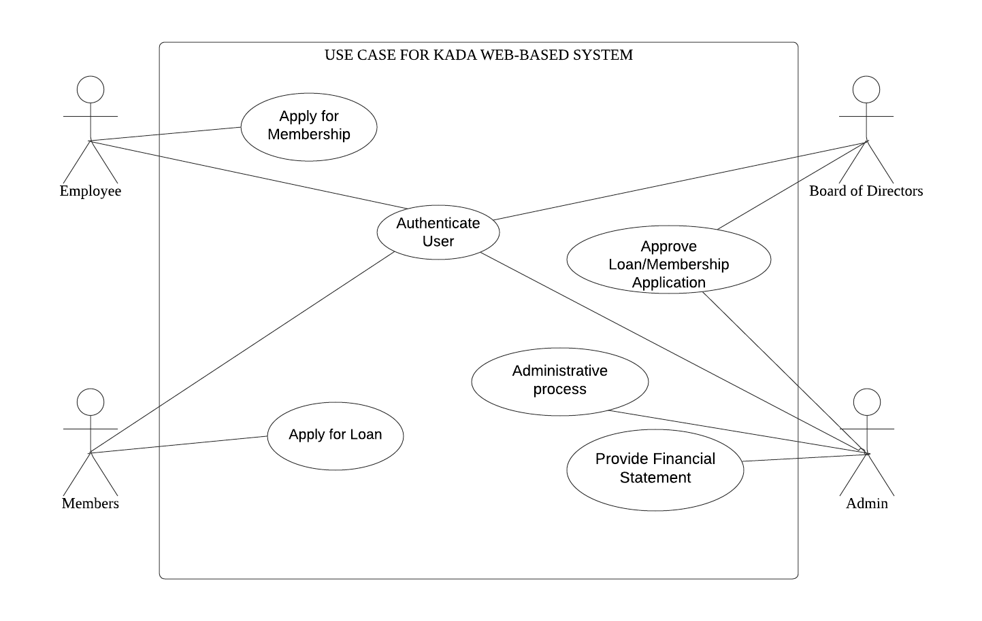
Figure 1.1 Use Case Diagram of KADA’s Cooperative Web-Based System

These are the technology that will be applied in the system:
- Apache HTTP Server
- PHP Technology
- MySQL
- JavaScript
- CSS
- HTML
- Bootstrap
- API
Table 1.1 shows the technology and its description to be used to develop this system project.

No | Technology | Description
1. | Apache HTTP Server | Used to handle high volumes of HTTP requests, managing client connections, and serving web content efficiently.
2. | PHP Technology | Will be used for dynamic web pages form submissions, and database interaction
3. | MySQL | Utilizing PHP scripts to retrieve, update, and manage information.
4. | JavaScript | Create dynamic and interactive web pages, faster load content to reduce response time.
5. | CSS | It will be used to design the interface to improve user experience.
6. | HTML | The backbone of the website that defines the content and structure of web content.
7. | Bootstrap 5 | This will be used to determine the design of the website from typography, forms, buttons, navigation, and other interface components.
8. | API | Allows the use of other applications within the website.
Table 1.1 shows the technology and its description to be used to develop this system project.

Glossary

Terms | Definition
Apache HTTP Server | An open-source HTTP server for modern operating systems including UNIX and Windows.
Application Programming Interface (API) | Defines how two applications communicate with each other using requests and responses.
Bootstrap 5 | A framework designed to ease the web development process of responsive, mobile-first websites by providing a collection of syntax for template designs.
Cascading Style Sheets (CSS) | A simple mechanism for adding style (e.g., fonts, colors, spacing) to Web documents.
Hypertext Markup Language (HTML) | The standard markup language for Web pages.
JavaScript | Defines the client side for webpage behavior
MySQL | An open-source relational database management system (RDBMS).
PHP Technology | An open-source, server-side programming language that can be used to create websites, applications, customer relationship management systems and more.

Bibliography

- What is an API? - Application Programming Interface Explained - AWS. (n.d.). Amazon Web Services, Inc. https://aws.amazon.com/what-is/api/

- Documentation Group. (n.d.). Welcome! - The Apache HTTP Server project. https://httpd.apache.org/
- Cascading style sheets. (n.d.). https://www.w3.org/Style/CSS/Overview.en.html

- Wikipedia contributors. (2024, November 5). HTML. Wikipedia. https://en.wikipedia.org/wiki/HTML

- Wikipedia contributors. (2024, November 15). MySQL. Wikipedia. https://en.wikipedia.org/wiki/MySQL

- Toal, R. (2023, October 23). A Comprehensive guide to PHP programming: What you need to know. Code Institute Global. https://codeinstitute.net/global/blog/what-is-php-programming/

- Wikipedia contributors. (2001, November 19). JavaScript. Wikipedia. https://en.wikipedia.org/wiki/JavaScript

- Alexandrea, J. (2023, May 19). What is Bootstrap? Hostinger Tutorials. https://www.hostinger.my/tutorials/what-is-bootstrap/

